**Assignment – 2: (Pijush Ghosh)**

* **Connect to the Store Sales Data and do the following: -**
* Remove all the blank rows
* Update the column header if they are not updated
* Create a text table and show the sales in terms of

o Customers

* + - * 1. o Product Category
        2. o Regions

Before transforming the data,

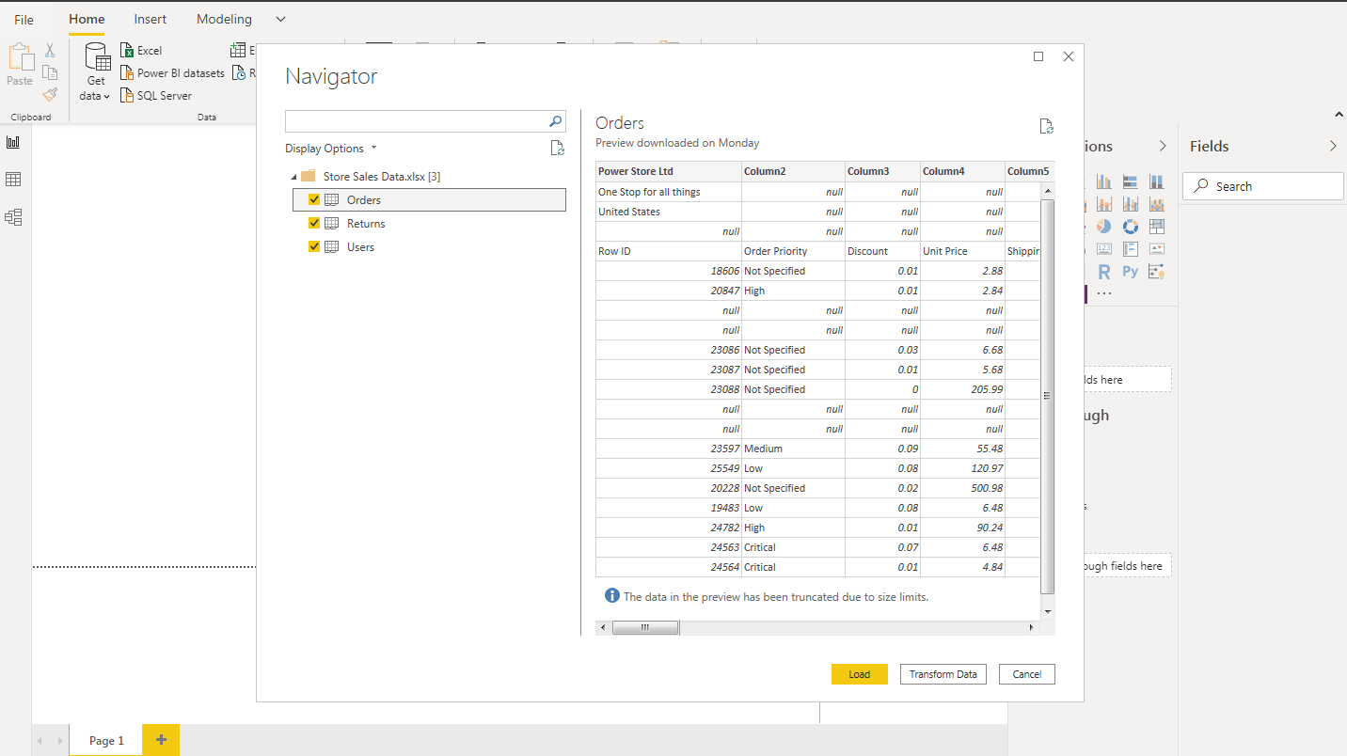

After Transform Data,

Removing all the blank rows –

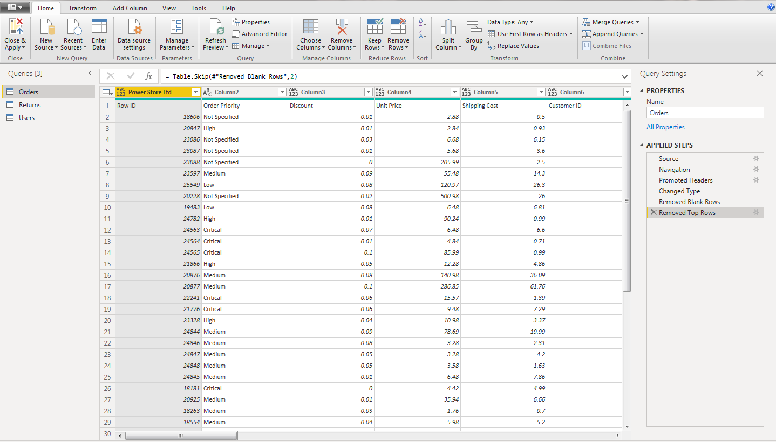

Updating the column header –

In Order table,

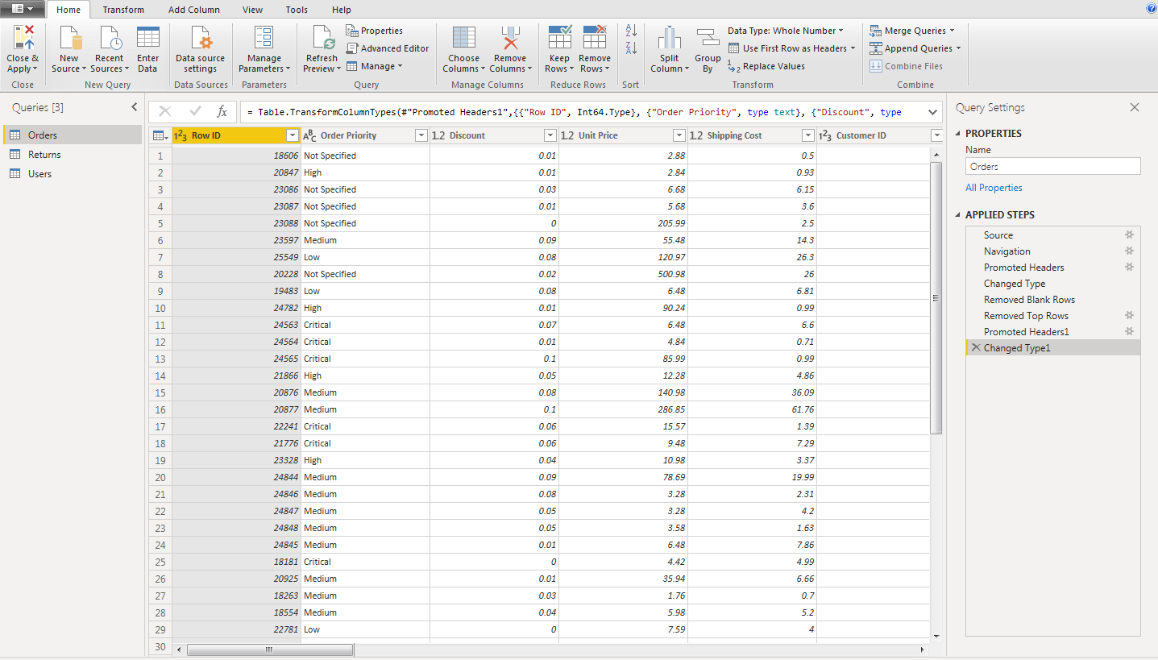

In User table,

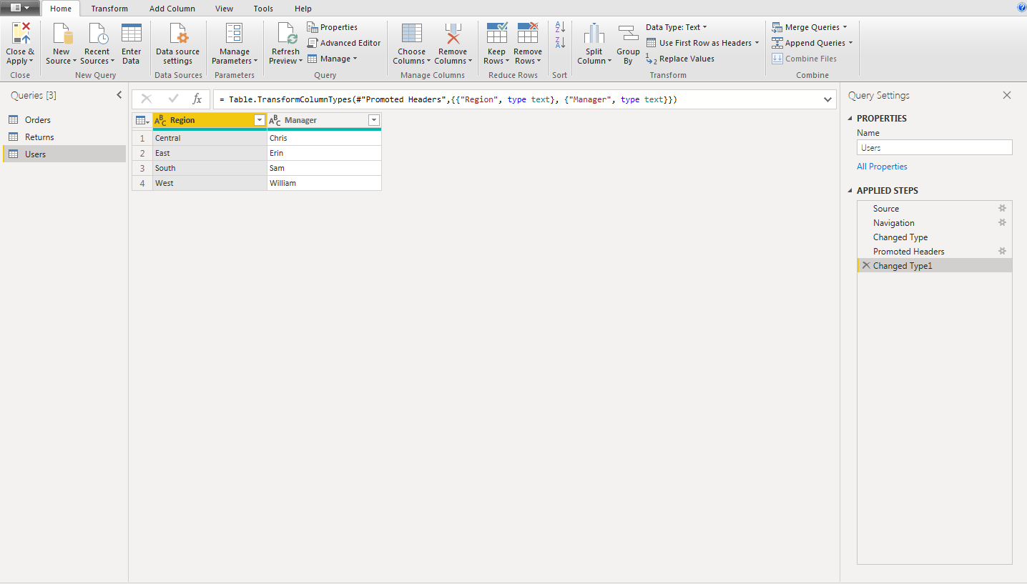

Report View (Text Table) –

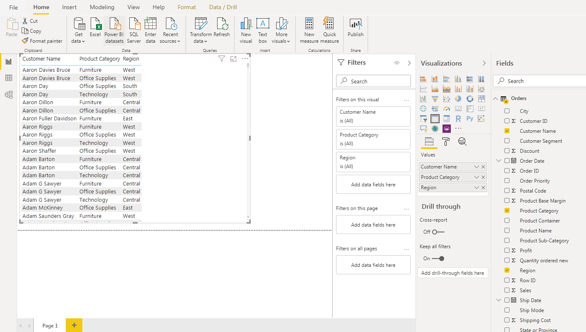

* **Create a line and Clustered Column Chart showing the Sales and Discount as per the State or Province**
* Format the bars and line with different colors
* Which state has the highest sales in terms Technology

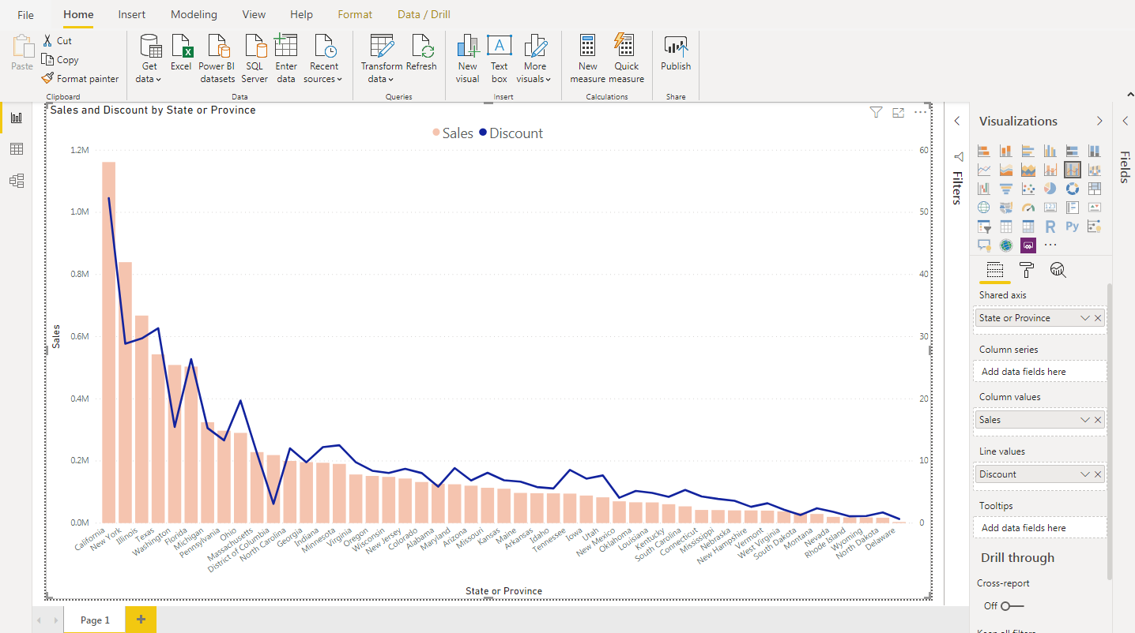

**The State ‘New York’ has highest sales in terms Technology**

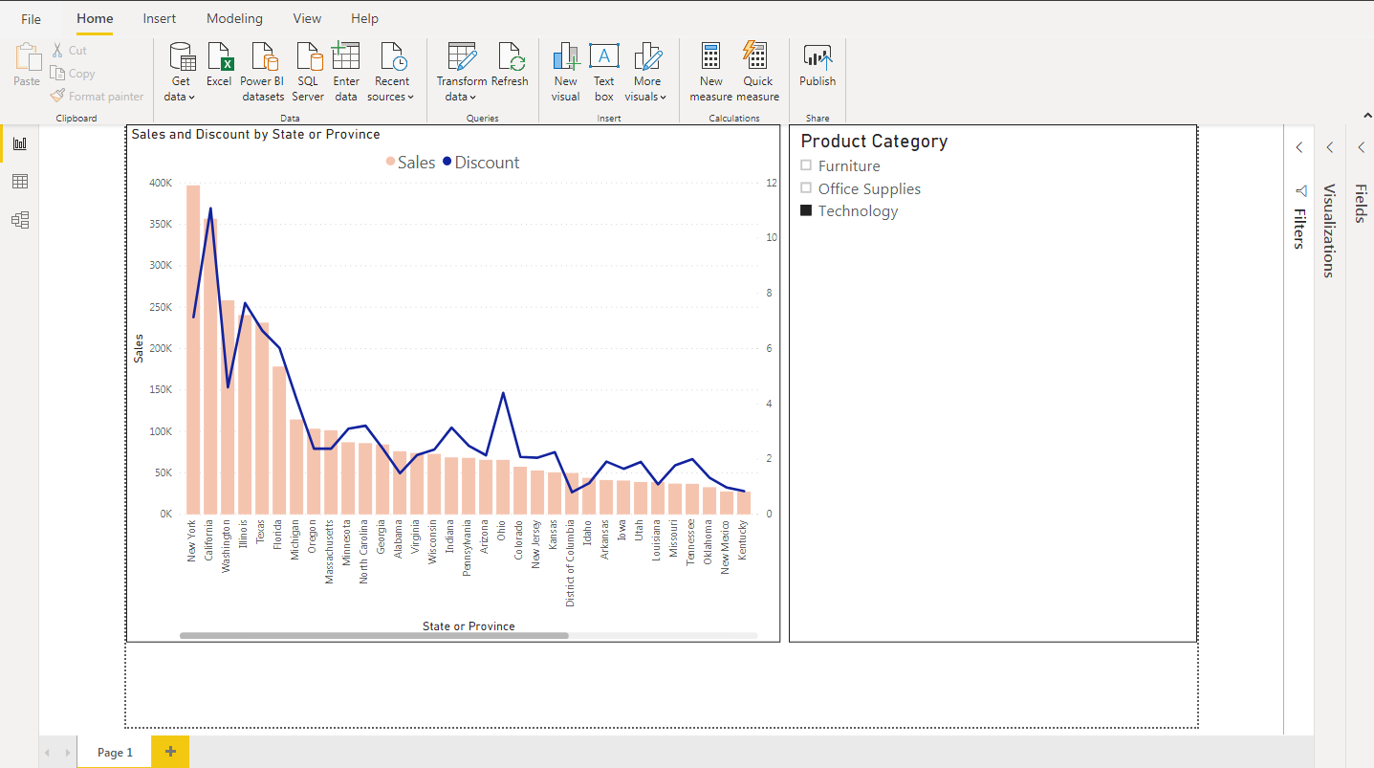

* **Create a** *Donut Chart* **showing sales in terms of Product category**

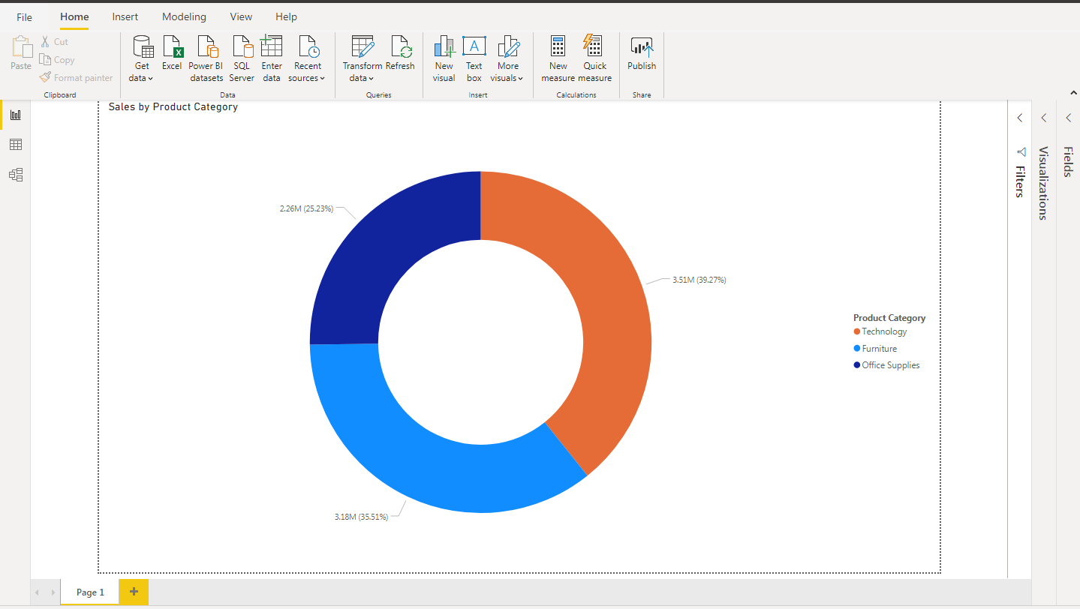

* **Create a** *Slicer* **and show the regions in dropdown. See how all the visuals mentioned above behaving when a particular region is selected.**

Region as ‘Central’

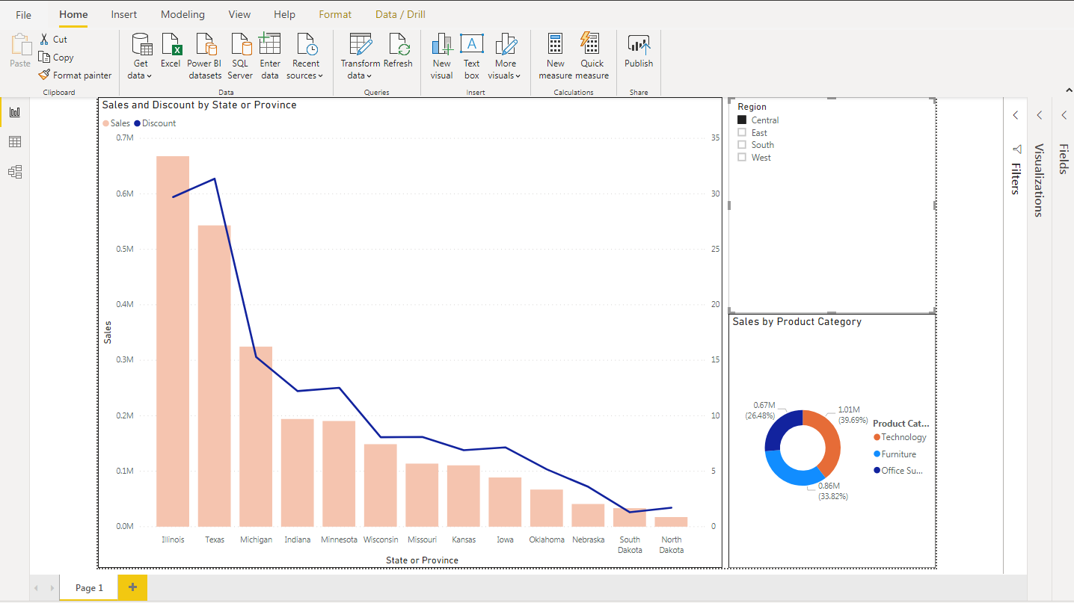

Region as ‘East’

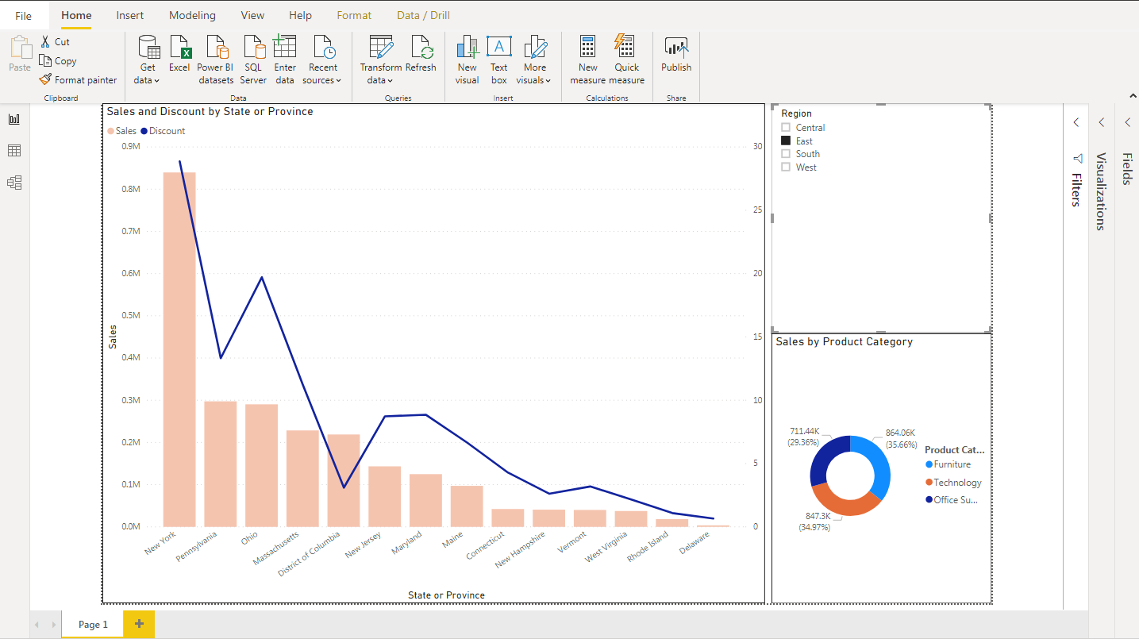

Region as ‘South’

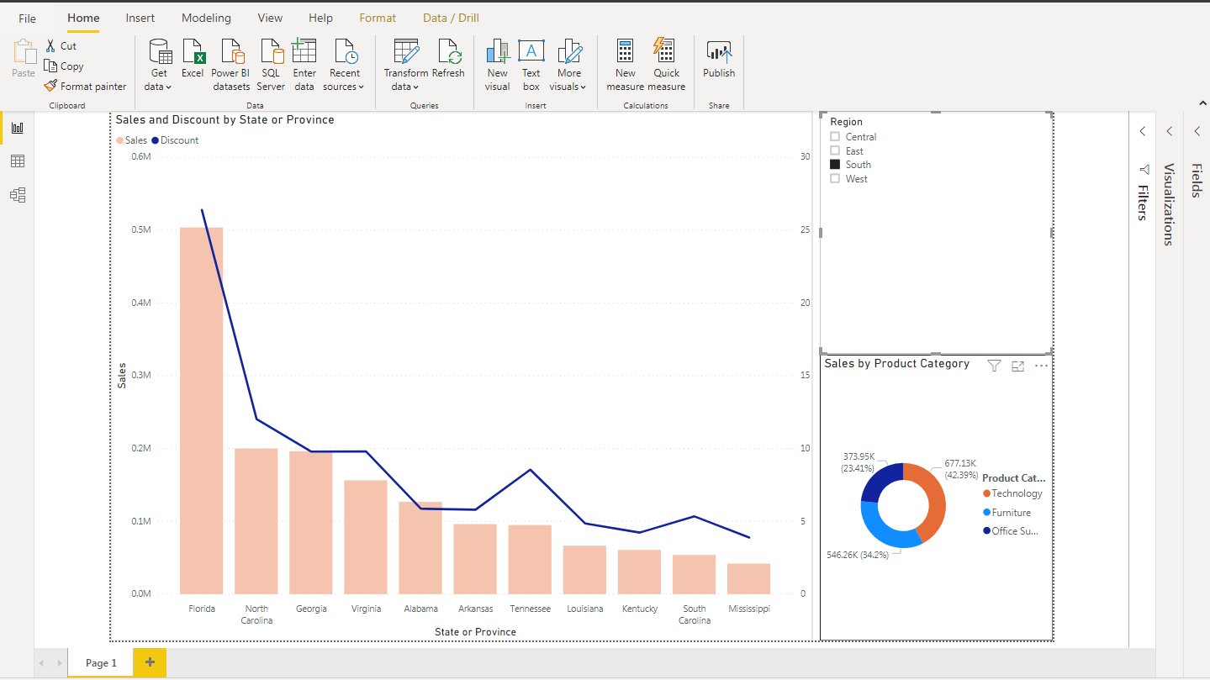

Region as ‘West’

